**FIT LOG - TO STORE WORKOUT CLASSES AND REPS**

**CS19611 - MOBILE APPLICATION DEVELOPMENT LAB MINI PROJECT REPORT**

***Submitted by***

**UDHAYA SHANKAR J (2116220701306)**

***in partial fulfillment for the award of the degree of***

**BACHELOR OF ENGINEERING**

***in***

# COMPUTER SCIENCE AND ENGINEERING



**RAJALAKSHMI ENGINEERING COLLEGE ANNA UNIVERSITY, CHENNAI**

# MAY 2025

RAJALAKSHMI ENGINEERING COLLEGE, CHENNAI

**BONAFIDE CERTIFICATE**

Certified that this Project titled **“Fit Log - to store workout classes and reps”** is the bonafide work of **“UDHAYA SHANKAR J(2116220701306)”** who carried out the work under my supervision. Certified further that to the best of my knowledge the work reported herein does not form part of any other thesis or dissertation on the basis of which a degree or award was conferred on an earlier occasion on this or any other candidate.

# SIGNATURE

## Dr. P. Kumar., M.E., Ph.D.,

**HEAD OF THE DEPARTMENT**

Professor

Department of Computer Science and Engineering,

Rajalakshmi Engineering College, Chennai - 602 105.

# SIGNATURE

## Dr. N. Duraimurugan., M.E., Ph.D.,

## SUPERVISOR

Associate Professor

Department of Computer Science and Engineering,

Rajalakshmi Engineering College, Chennai-602 105.

Submitted to Mini Project Viva-Voce Examination held on

**Internal Examiner External Examiner**

# ABSTRACT

# Workout Planner is a Kotlin-based Android application developed for users to efficiently track and manage their daily workout routines. It allows users to store workout information such as name, equipment used, number of sets, repetitions, and weights in a local SQLite database. Users can view their workouts, add new ones through a form, and remove completed workouts with ease.

# The app features a clean and minimal user interface, designed with XML layouts and Kotlin logic. It uses SQLite for persistent storage and provides a smooth experience even offline. The modular code structure makes it easy to extend functionality in the future.

# This app is especially useful for fitness enthusiasts, trainers, and anyone who wants a simple yet powerful tool to manage their fitness regimen on the go.

# 

# ACKNOWLEDGMENT

Initially we thank the Almighty for being with us through every walk of our life and showering his blessings through the endeavor to put forth this report. Our sincere thanks to our Chairman **Mr. S. MEGANATHAN, B.E, F.I.E.**, our Vice Chairman **Mr. ABHAY SHANKAR MEGANATHAN, B.E., M.S.,** and our respected Chairperson **Dr. (Mrs.) THANGAM MEGANATHAN**, **Ph.D.,** for providing us with the requisite infrastructure and sincere endeavoring in educating us in their premier institution.

Our sincere thanks to **Dr. S.N. MURUGESAN, M.E., Ph.D.,** our beloved Principal for his kind support and facilities provided to complete our work in time. We express our sincere thanks to **Dr. P. KUMAR, M.E., Ph.D.**, Professor and Head of the Department of Computer Science and Engineering for his guidance and encouragement throughout the project work. We convey our sincere and deepest gratitude to our internal guides **Dr. N. DURAIMURUGAN,** We are very glad to thank our Project Coordinator, **Dr. N. DURAIMURUGAN** AssociateProfessorDepartment of Computer Science and Engineering for his useful tips during our review to build our project.

**UDHAYA SHANKAR J 2116220701306**

**TABLE OF CONTENTS**

**1. INTRODUCTION**

**1.1. INTRODUCTION**

**1.2. OBJECTIVES**

**1.3. MODULES**

**2. SURVEY OF TECHNOLOGIES**

**2.1. SOFTWARE DESCRIPTION**

**2.2. LANGUAGES**

**2.2.1. KOTLIN**

**2.2.2. XML**

**2.2.3. SQLITE**

**3. REQUIREMENTS AND ANALYSIS**

**3.1. REQUIREMENT SPECIFICATION**

**3.2. HARDWARE AND SOFTWARE REQUIREMENTS**

**3.3. ARCHITECTURE DIAGRAM**

**3.4. ER DIAGRAM**

**3.5. NORMALIZATION**

**4. PROGRAM CODE**

**5. OUTPUT**

**6. RESULTS AND DISCUSSION**

**7. CONCLUSION**

**8. REFERENCES**

**CHAPTER I**

**INTRODUCTION**

**1.1 GENERAL**

# Child development programs such as ICDS are very crucial for monitoring a child’s health while also increasing their educational focus and opportunities. It mainly faces challenges related to manual data entry either in physical means of digital which can lead to errors. At some level every project requires automation to reach the next level. The low level of community engagement produces a negative effect on the service delivery.

# Anganwadi centres are still relying on handwritten registers which is not only inefficient on workers but also prone to error and delay. It is difficult to monitor child growth consistently when services do not have connectivity at a consistent level leading to a need for a combination of offline and online systems. The availability and reliability of the internet greatly increases the odds of a digital system approach.

# This paper addresses the concerns of child growth and attendance measurement by introduction of BMI machines, decentralized local data storage, mobile apps to make it easier to track services and to improve public engagement for ICDS programs.

# 1.2 OBJECTIVE

# The objective of “Smart Health And Attendance Management System For Child Development Programs” is to to develop a modular platform to digitise child growth tracking, implement attendance tracking with decentralized storage, and encourage public participation in Integrated Child Development Services (ICDS) by incorporating gamification to the solution. The system will help to improve their accuracy of data collection by using BMI machines for accurate height and weight collection, reduce server load by implementing attendance systems that operate on blockchain, and increase enrollment through awareness campaigns and rewards to participate. In addition, focus will be applied to provide support of multiple languages, offline use of the platform, and privacy of the data; to ensure all aspects of the system are inclusive and usable among various populations, especially those with remote access. Access will be able to provided to only the required features for Anganwadi workers, administrators, and parents in a user-friendly interface to instill trust and access services consistently in the Integrated Child Development Services (ICDS) ecosystem.

# 1.3 EXISTING SYSTEM

# Current mechanisms for counterfeit account detection are based on centralized algorithms that rely heavily on human moderators. Given the existing fake accounts already being more advanced than most counterfeiters, both forms of detection are still not very reliable in determining counterfeit from counterfeit accounts. Centralized unique identifiers and other identifying methods are limited in their ability to protect privacy or personally identifiable information. Centralized detection methods are also generally always exploitable since centralized databases can be breached, hacked into, or accessed illegally which can entirely compromise a user’s privacy and sensitive information. The methods are also not transparent. Users deserve security and transparency when it comes to protecting mischievous users proliferating counterfeit profiles which are a form of digital unaccountability. Last of all, weak detection systems allow identity thieves to create fake profiles ruining the social experience for users, flourishes improvable practices such as misinformation or fraud, and deteriorates trust on the social platform. Today, there exists an even bigger need for a new approach to prevent these issues and make spaces in a digital world a better, safer, reliable place with appropriate action to end the threats.

# CHAPTER 2 LITERATURE SURVEY

"A Student Attendance Management Method Based on Crowdsensing in Classroom Environment" [1] (2024) by Zhigang Gao, et al. At this paper, AMMoC is introduced, which stands for Attendance Management using Crowdsensing. AMMoC is a completely new student attendance management tool directed towards enhanced efficiency and deduction of the risk of fraudulent check-ins in a classroom environment. Classes of standard attendance, for example, include roll call and used to be sometimes basis on RFID; but few limitations like inefficiency, expensive nature, and susceptibility to cheating plagued them. The approach of AMMoC deals with these problems by mobile crowdsensing, where students upload their location data using mobile applications. The classroom is partitioned into teleregions, and the task assignment for student verification is optimized using Monte Carlo Tree Search (MCTS). Selected students shall dismantle and ascertain attendance in specific regions so that there should be a likelihood of mutual verification. The autonomy phase analyzes for the instances of any inconsistencies and detects possible cheating. AMMoC brings in an array of advantages against distances pertaining to other biometric and RFID-based systems such that incurring costs associated with minimal disruptions of the class and higher accuracy is achieved. The experimental results show AMMoC's applicability in curtailing students' fraudulent attendance with broader students subjected to checks. As this system well fits the larger classroom arena, it could be extended with customizations towards online learning modes sometime in the future.

"Improving the Accuracy of Adult Height Prediction With Exploiting Multiple Machine Learning Models According to the Distribution of Parental Height" [2]. This study aims to improve the accuracy of predictions of adult height movement by the use of several machine learning models constrained by the parental height distribution. Growth charts and other traditional methods have often proved less adaptable to different populations and have depended on lengthy longitudinal studies in their analyses. To fill this void, data were obtained on the heights of 2,687 Korean men and women. They replicated Galton's 19th-century dataset, asking how parental heights affected children's heights. Results from the Korean data indicate maternal ties exerted much more impact upon daughters' heights, while Galton's work suggested the influence of fathers on growth. Using software featuring several machine learning core typesincluding linear regression, support vector regression, XGBoost, and LightGBM-the study grouped parental heights into quartiles and selected optimal models for each subgroup, resulting in extremely considerable accuracy improvements. This technique provides < 3.5 RMSE, outperforming single-model predictions, which often have RMSE >4.0. Findings reinforce a call for population-specific data, application of advanced modeling paradigm issues for accurate height prediction, and implications for pediatrics, parents, and growth-monitoring researchers.

"SCHOOLTHY: Automatic Menu Planner for Healthy and Balanced School Meals" [3] The paper presents SCHOOLTHY-an automated menu planning system intended to create healthy and balanced meal choices for school canteens. Malnutrition resulting from nutrient deficiency or excessive consumption of processed foods is a growing concern, especially among children. Traditionally, school meal planning has been done manually by nutritionists-a painstaking, tortuous, and inefficient task.SCHOOLTHY transforms the labor-intensive manual method into an advanced automated menu generation process that is evolutionarily optimized to create a cost-efficient, nutritionally balanced, and varied menu. This system is capable of optimizing several objectives, including the minimization of costs, maximization of dietary diversity, and adherence to nutritional guidelines. SCHOOLTHY employs a multi-objective optimization strategy, ensuring that the meal plans meet energy and macronutrient requirements while reducing food repetition. The research evaluates the meal plans generated by SCHOOLTHY against those crafted manually by experts, revealing that the automated method not only offers superior nutritional value but is also more economical. SCHOOLTHY is flexible in a way that it could be adopted in other institutional settings, such as hospitals and nursing homes. The study demonstrates the capability of such AI-powered decision support tools as nutritional planning tools, presenting the ability to scale up quality and efficiency in the foodservice industry.

"Promoting Obesity Prevention and Healthy Habits in Childhood: The OCARIoT Experience" [4] (2024) aims to enhance privacy and security in facial recognition systems through the use of Generative Adversarial Networks (GANs) and blockchain technology. The primary focus of the study is to generate synthetic faces with GANs, which help protect personal identities while ensuring recognition accuracy. Blockchain technology is employed to manage these synthetic identities in a secure, decentralized manner, providing a tamper-proof and transparent system for data verification. This integration significantly improves the privacy of facial recognition systems by preventing unauthorized access and ensuring data integrity. Despite the promise of this approach, a major limitation lies in its dependence on GAN-generated synthetic data, which may lead to inconsistencies in real-world applications where highly accurate facial features are required. Addressing these challenges is crucial for the effective and scalable deployment of this system in various practical scenarios.

"Smart attendance system based on frequency distribution algorithm with passive RFID tags" [5] The paper presents a smart attendance system that employs Radio-Frequency Identification (RFID) technology for attendance tracking in workplaces and minimizing fraudulent attendance. The existing methods like manual punch cards and fingerprint scanning are subject to manipulation or potential hygiene issues and are unfit. The RFID system designed taps the passive RFID tags and simulates the unique phase characteristics of an individual, allowing for device-free recognition using biological characteristics. The frequency distribution algorithm generates a statistical fingerprint of an individual, refined with K-means clustering to separate people having similar physical characteristics. The widespread testing suggests that the system is 92% accurate while being robust against clothing or the environmental conditions. And as such, this approach offers great improvements over the conventional fingerprint or facial-recognition systems, reducing confusion surrounding direct hardware interaction, thus increasing both security and ease-of-use. Findings show that RFID-based approach addresses issues in attendance management and offers a scalable and anti-cheating alternative in corporate environments. Future work, however, will focus on real-time processing and making the system applicable for larger populations.

"Face Recognition Attendance System Based on Real-Time Video Processing" [6] In this paper, we present the development of an attendance system based on face recognition that features real-time video processing for improved accuracy and efficiency. Traditional methods of taking attendance, such as fingerprint scanning or manual check-ins, suffer from inaccuracies, inefficient tendencies, and fraudulent acts such as proxy attendance. To alleviate this situation, artificial intelligence and computer vision are introduced in the attendance system in this system to automatically detect and authenticate the student identity for attendance taking. The study evaluated the system's recognition precision, stability status, and overall reduction in truancy based on the effectiveness of the interface among the users. The findings show an 82% recognition accuracy for the face recognition system, with marked improvement in attendance tracking when weighed against the manual method. The system also reduces the amount of time a student is absent from the classes, and absentees fall to value not more than one-third of the entire student populations. This automatic system obviates the need for manual roll-taking in the institution by lessening the burden of classroom management. There may be issues such as incorrect data due to inadequate lighting or occlusions of facial features that e threatened the efficacy of the system, yet this paper indicates that real-time video facial recognition is a good and scalable attendance monitoring system. Further enhancements will focus on improvement in recognition abilities for various conditions and expanding the above monitoring system to other institutions.

"Detecting Subtle Signs of School Attendance Issues Using Smartphone-Based Sensing" [7] This paper describes a smartphone-based system that detects signs of attendance problems early on. Attendance problems, related to sleep disorders and fewer indicators of academic engagement, can lead to course failures and dropouts. But students tend to delay help until problems develop, so it is imperative to intervene early. To this end, the researchers designed a mobile application that passively gathers data from commonly available sensors in smartphones and does not require additional wearable devices. The system uses machine learning models that analyze sleep and study engagement levels trained on data collected from 58 students over ten months. Their results show that the system could estimate how well a student is sleeping and how engaged the student is, providing reliable indicators of students who are at risk. The ability to monitor students on a larger scale, unobtrusively and without disruptions to normal routines, is contrary to the manner of traditional face-to-face counseling. The study emphasizes that the system is not meant to replace medical examination but helps to identify at-risk students for acquiring timely support. Future improvements will be focused on additional accuracy, wider applicability, and reinforcement of feedback mechanisms to maintain student feeling well and performing well.

"Enhanced Efficiency in SMEs Attendance Monitoring: Low Cost Artificial Intelligence Facial Recognition Mobile Application" [8]The paper discusses the development of an inexpensive attendance monitoring system based on facial recognition techniques meant specifically for Small Medium Enterprises (SMEs). With the introduction of remote and distributed working models for employees, attendance tracking has become a nightmare, especially for SMEs that do not afford to spend on exorbitant biometric systems. In light of this challenge, the authors suggest the development of a mobile application that employs artificial intelligence interface with facial recognition as well as location analysis for a cheap and effective attendance management system. The system employed deep learning models with particular reference to ResNet34 with Additive Angular Margin loss to ensure high accuracy for real-time face detection and identification. The mobile app was developed with React Native on the front and NodeJS and Python at the back end and aimed at seamless functionality on both mainstream platforms: iOS and Android, therefore making it available to many SMEs that do not have advanced IT abilities. The study found that the system's accuracy was generally around 92%, thereby minimizing the errors and eliminating problematic frauds in attendance such as buddy punching. Finally, cloud processing solves the computation requirements for mobile devices while at the same time providing scalability and a security mechanism for data throughout the technol. The study shows the feasibility of AI-based facial recognition as a more applicable and very affordable way of managing a greater workforce within an SME.

"Improving the Working Memory During Early Childhood Education Through the Use of an Interactive Gesture Game-Based Learning Approach" [9] The paper examines how interactive gesture-based game learning (GIGL) might positively impact working memory and basic mathematical skills in early childhood. This study investigates whether children (5-6 years old) can stimulate cognitive development through learning by motion rather than traditional methods of instruction. The experimental group was involved in a gesture-based game environment, while the control group engaged in teacher-directed activities. The working memory was measured through the Corsi task, while basic mathematical skills were evaluated through the TEDI-MATH measure. GIGL children demonstrated improvement to a point much higher than that of their control counterparts. This is seen as motivation, interest, and cognitive growth through movement in the learning activities. The possibilities offered by HCI will increase attention and key cognitive abilities in young learners, using gesture technology to integrate mobile learning into the school curriculum with fun. The inference here is that gesture-based educational games would vividly testify to the continued injection of interactive technologies into early education. Further studies look to advance the efficaciousness of such tactics and their enduring effects in child development.

"Digital Game-Based Technology for English Language Learning in Preschools and Primary Schools: A Systematic Analysis" [10] The paper gives a systematic review of digital game-based learning technologies for teaching English as a foreign language in preschools and primary schools. In this regard, the authors analyze 110 studies published between 2010 and 22, focusing it on how DGBL enhances motivation, creativity, and problem-solving skills among young learners. They propose a classification model for DGBL that takes into consideration game design principles, pedagogical aspects, language content, and feedback mechanisms so as to provide better educational outcomes. The study catalogs 50 key studies that focus specifically on children between ages 2-10 and hence emphasize interactive and engaging learning instances. While DGBL is in fact very effective, the review also spins a spandex web of some nontrivial difficulties that swaddle DGBL into its own potential, like health, technology accessibility, and preparation of the teachers. The authors state that perhaps the enumeration of some emerging technologies, for instance, artificial intelligence and blockchain, augmented reality will address some of these hindrances to optimization and scalability of DGBL. The work highlights the vital importance and need of developing structured models for games tailored to the young learners while suggesting further research that should extend into automated assessments and progression tracking of students. The insights derived from the paper serve to be valuable for educators, game developers, and policymakers that aim to incorporate game-based learning into the early education curriculum.

"An IoT-Based Approach for Learning Geometric Shapes in Early Childhood" [11] (2024) The paper proposes an IoT-based way of teaching variety of geometric shapes to young children, so as to make this learning more interesting and effective. Geometry, an important subject in the development of spatial awareness and problem- based learning, has often been neglected in early childhood education.The findings indeed showed that children were able to recognize shapes and retain more information as compared to traditional approaches. The fact that many children reported fun and enjoyment while engaged in interactive learning indicates the motivation potential of technology within early childhood education. Additionally, a significant number of children reported enjoyment and satisfaction with the interactive learning experience, implying that technology has the potential to boost motivation in early childhood education.Although the research has primarily targeted boys, further studies can validate the claim further for mixed-gender sampling and larger sample sizes. Future works may further examine long-term learning and retention, as well as possibilities of incorporating other related mathematical concepts, in the area of IoT transforming early childhood education.

"Distributed Data Strategies to Support Large-Scale Data Analysis Across Geo-Distributed Data Centers" [12] A paper discussing the techniques and approaches for managing and analyzing large-scale data that is distributed across several geographically separated data centers. Due to high volumes of big data, storing and processing all data from a single location become impractical: bandwidth constraints, security concerns, and high operation costs are just but a few of the reasons. The authors propose two distributed data strategies that allow for efficient analysis without the need to move entire datasets over long distances. The first one is designed for data stored without replication; by selecting data blocks based on a Random Sample Partition technique, a sample will be chosen from each data center and sent to a central server for approximate analysis. The second strategy relies on the replication of certain key data blocks across the different data centers, hence allowing the analysis to be carried out at any one of these sites without the need for large-scale data movement. Both techniques aim to reduce network traffic and increase efficiency of processing while ensuring accuracy through random sampling methods.

"Deep Learning-Based Data Storage for Low Latency in Data Center Networks" [13] The paper presents a novel methodology for data storage based on deep learning techniques, aiming to minimize latency in data center networks. As cloud computing and data-centric applications burgeon, traditional static data-accommodation models are losing their grip to effectively adapt to changing networks and dynamic user requests whose outcomes often slow down data retrieval. The authors developed an analytical-based k-means clustering approach, which dynamically optimizes data placement into closer regions through the group-allocation of hot data blocks. Taking advantage of the previous work of access to avoid unnecessary data transfers, this system cuts read and write latency. The simulation work on a Fat-Tree DCN topology demonstrates the 33% average reduction in write latency and 45% average reduction in read latency over static storage schemes. An exhaustive analysis is also performed to comprehend the optimal value of 'k,' dependent on the number of cores in a given network for the proper distribution of available resources. The importance of learning-based storage management in improving cloud computing efficiency, reducing network bottlenecks, and improving system performance is brought out. Future work will include reinforcement learning and other refinement of AI techniques for data placement in very large-scale distributed systems.

"Automatic Prediction of Children's Reading Ability for High-Level Literacy Assessment" [14] The paper presented an automatic literacy assessment system, which had been dedicated to investigation of children's reading abilities using machine learning and speech processing. Manual assessments commonly used until now needed to be executed on admissions by three or more evaluators; minutes were spent to recast, and there was no definite rule as how to differentiate between reading types. As a very interesting alternative, the study developed an automated system to analyze children's spoken word recordings in predicting their overall reading proficiency. The research could be divided into two main studies: a human evaluation study, where 11 evaluators rated children's reading abilities from audio recordings, and a machine learning experiment, which trained models to predict human scores based on speech features, including correctness of pronunciation, fluency, and speaking rate. In testing, the model was validated using recordings from kindergarten to second-grade experienced children from English-speaking and Spanish-speaking backgrounds. The results concerning the prediction of reading ability showed a Pearson correlation at 0.946, which surpassed human agreement inter-evaluators. The study gives substantial hope that the technology could increasingly replace teachers with computer-based literacy assessment in the classroom, allowing teachers objective, repeatable feedback with the lightening of the burden of manual ratings.

"TELEMEDICINE AND RURAL HEALTHCARE ACCESS: A COMPARATIVE ANALYSIS OF EMERGING TECHNOLOGIES" [15] The present paper discusses the effect telemedicine has on healthcare access in the rural areas by focusing on ways through which telecommunications can overcome spatial boundaries, making travel burden for patients light, and providing medical outcomes. The problem that these rural populations face is that health services are often underdeveloped and, as a result, patients are unable to seek medical attention at the right time due to lack of access. To this end, a mixed-methods design was employed that involves quantitative analysis of patient data and quantitative interviews with both healthcare providers and patients themselves. The study shows telemedicine to have reduced wait times by 57% and hospital readmission by 20%, while improving patient satisfaction by 21%. The primary challenges of telemedicine are limited broadband access, financial abilities of small healthcare facilities, and varying telemedicine reimbursement policies. It goes on to discuss how some advances such as artificial intelligence, mHealth application, and blockchain may bring about change to the tasks and act to assist telemedicine to become better. It posits that the policy interventions are needed to make the broadband rollout more widespread, telemedicine regulation is further standardized, and funding is increased to facilitate telemedicine in practice. The study concludes that the potential of telemedicine in ameliorating the inequities in health systems amongst rural folks will be at its best, but for that, advancements with technology, streamlining of regulations, and infusion of capital into the sector need to follow.

"ENGAGING THE COMMUNITY IN HEALTH RESEARCH IN INDIA" [16] This paper discusses community-engaged research (CER) in the context of improved public health outcomes in India. In CER, community members actively participate in all different stages of research so that interventions shall be culturally appropriate and efficacious. The study screened for 15 research articles based on community engagement published in India. Most studies indicated health promotion initiatives targeting HIV/AIDS prevention, menstrual hygiene, and infant healthcare. CER offers the first-level exposure of community needs, behavior, and challenges; however, it was noted in the study that there was no report where community members defined by themselves issues to be handled. It was observed that the involvement of the community leads to increased participation in health programs, awareness, and improvement of health-seeking behavior. At the same time, the problems include limitations of funding, a hierarchical structure for decision-making, and the fact that internal participation could not be sustained for a long time. This paper suggests CER is widely practiced in high-income countries; however, its application in India is scanty. The authors called for the widening of CER to chronic disease management, biomedical research, and health policymaking so as to enhance that impact. They accentuated the need for more extensive academic participation of Indian researchers along with increased collaboration between communities and policymakers to invigorate public health initiatives.

"Private cloud solution for Securing and Managing Patient Data in Rural Healthcare System" [17] Most rural healthcare systems, characterized by a lack of software applications, focus on paper-based records management. The ongoing transition to digital in healthcare continues to pose security risks in the management of medical information in rural areas. To tätäva into considerations, they introduce a private cloud infrastructure whereby data service delivery is ensured for the protected, fast, reliable, accessible, and scalable data service. Operating using a dual-database system, with one database handling medical records and another dealing with encryption keys for added security, it preempts decryption unauthorized access. The data transmitted is subjected to hashing and encryption processes for fulfilling two prerequisites: confidentiality and integrity compliance. The end result is that healthcare providers can access patient records conveniently; medical decision-making improves while data breach risks are reduced in rural clinics deploying the cloud solution. The paper also emphasizes that cloud technology adoption helps bridge the rural-urban divide in healthcare service access, where medical records can be accessed much faster without compromising data privacy. This proposed system is consistent with the objectives mandated by Digital Healthcare in India, aimed at modernizing patient data management and, in turn, improving service delivery efficiency in marginalized areas.

"Use of mobile app to monitoring growth outcome of children: A systematic literature review" [18] This paper analyses the use of mobile applications in monitoring child growth outcomes, particularly focusing on children with poor nutritional status, including undernutrition and obesity. The scenario around the digital health solutions suggests that mobile applications represent a great potential method for tracking growth metrics, helping educate parents and caregivers, and supporting early intervention. The 12 studies subject to systematic review are those that evaluate the effectiveness of mobile applications in improving child nutrition and development. The findings show that of these studies, six indicated mobile application-aided growth monitoring and parents' knowledge gains acted to positively impact on children with under-nutrition in offering better nutritional care, while six others found that mobile apps were helpful in promoting healthy behaviors and providing weight management strategies for overweight or obese children. These applications enable the tracking of growth parameters, including comparisons to standard growth charts and offering recommendations for intervention, by caregivers and health workers. However, identified challenges include security of data, access to networks, and the need for more validation of self-reported data. The research suggests the real potential for mobile health technology to improve child nutrition monitoring and to address growth-related concerns in early detection.

"Response and adaptations made by the integrated child development services stakeholders towards the digitalisation of its record keeping systems of the Anganwadi centres in urban Gujarat, India" [19] This paper analyses the transition from conventional record-keeping to rational data management systems in Anganwadi centers of India's Integrated Child Development Services (ICDS) programme. Initially, the ICDS-CAS software was introduced in 2018 into the programme for near-real-time monitoring of nutrition and maternal health services for children. However, it was discontinued in the year 2020 and subsequently replaced with Poshan Tracker in 2021. The study evaluates the extent and challenges and benefits of this transition with the help of discussions with Anganwadi workers (AWWs), supervisors (AWS), and Child Development Project Officers (CDPOs) in urban Gujarat. The findings reveal young AAWs adapt very well, older worked better with registers. Problems included low storage space in ICDS-CAS, lack of auto-update and delete commands in Poshan Tracker, and language challenges (software was only available in English opposed to Gujarati). Quality of the mobile devices provided for data entry was another red flag, with routine malfunctions interrupting the workflow. Moving to this format of record-keeping makes the management of data access much easier by cutting down other paper work for supervisors and tracking home visits. In conclusion, the paper highlights that digital systems add value by bringing more efficiency in growing the workload; however, it is incumbent on better training for users and support for devices and software improvements to accommodate the different user needs.

"Assessment of Growth Monitoring Activities Conducted in Anganwadi  
Centers" [20] presents a method for detecting fake media using natural language processing (NLP) and blockchain technologies. It integrates NLP for content analysis and blockchain for verifying media authenticity, enhancing trustworthiness in digital media.

**CHAPTER 3**

**PROPOSED SYSTEM**

* 1. **GENERAL**

The proposed system focuses on addressing the challenges faced by Anganwadi centres in monitoring child growth and attendance in a more efficient way. Instead of using manual physical entries ,complex IoT devices, the solution uses a BMI machine to record children’s height and weight, with a data transfer to the software platform. Attendance is managed through the software along with the BMI of each child on a daily basis. The new data is updated in bulk to minimize the server load. A mobile application for parents, guardians to provide child engagement by providing access to growth reports, attendance history, reminders and educational content. Additionally it promotes regular check-ups and participation through a system.The system also supports multiple languages, offline functionality and security. Even in remote areas the data can be collected reliably and synchronized in connectivity. Through modular, scalable decentralized systems and user-friendly interface, the system aims to improve child health and attendance monitoring and increase community involvement in Anganwadi centres.

# SYSTEM ARCHITECTURE DIAGRAM

The system architecture (fig 3.1) presented here, depicts a decentralized child monitoring platform with modular components that provide digitized growth records, a blockchain based secure attendance system and community engagement through mobile apps. It demonstrates how to bring together independent BMI machines that can be used to collect reliable height and weight measurements that form the basis of the Growth monitoring Dashboard. Data will be collected locally on SQLite, which can be accessed offline and then uploaded when a secure connection is possible to the back end (Node.js or Django).

There are two contexts of the Web Frontend - Anganwadi workers/administrators and parents, supporting role-based access. The Attendance Tracking System could be utilizing a lightweight blockchain to provide immutable records of attendance and promotes accountability and transparency. Attendance logs to be queried for growth/attendance information, together with growth data architectures will substantiate some engaging platform for the Community Engagement Platform. The logs of attendance, spatial awareness messages and rewarding are located on the Community Engagement platform, enabling the design of an automated alert / awareness message and distributed rewards when attendance is recorded.

The decentralized aspects of the data provides secure data storage, provides us ability to operate scalable physical existence of many Anganwadi centers. Our architecture supports multilingual and offline access capabilities, making it possible to deploy in limited connectivity rural environments. Overall, our system complements modular components for effective, extensible and human-centered services while keeping server demands low with summarized and decentralized data.

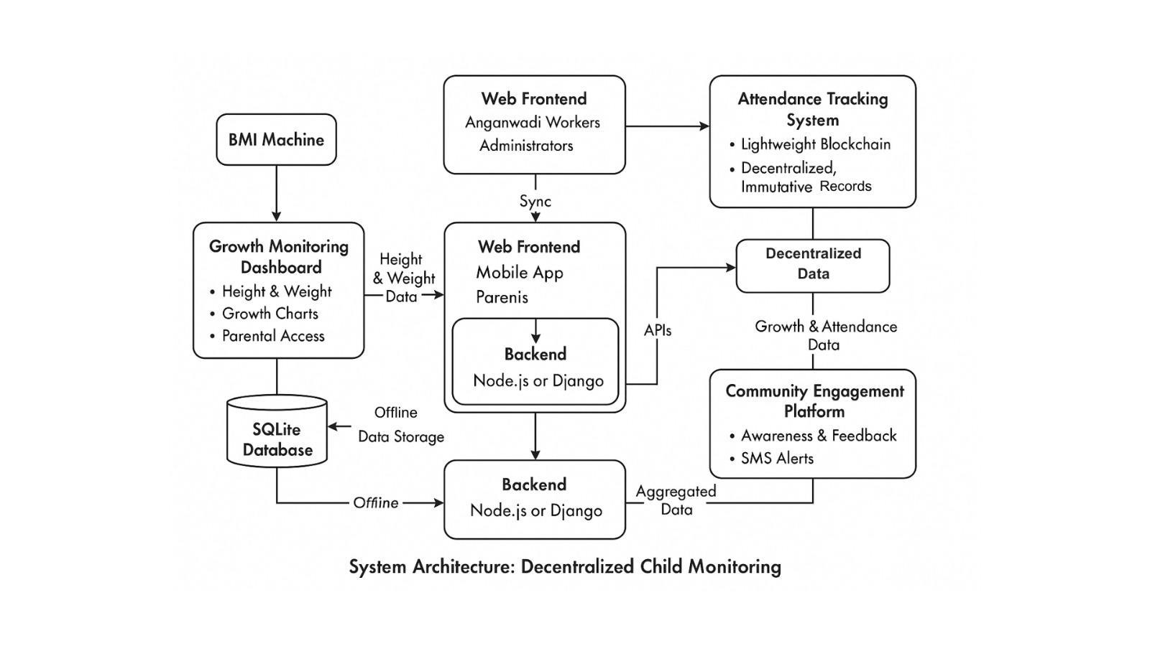

**Fig 3.1: System Architecture**

# DEVELOPMENTAL ENVIRONMENT

* + 1. **HARDWARE REQUIREMENTS**

The hardware specifications could be used as a basis for a contract for the implementation of the system. This therefore should be a full, full description of the whole system. It is mostly used as a basis for system design by the software engineers.

**Table 3.1 Hardware Requirements**

| **COMPONENTS** | **SPECIFICATION** |
| --- | --- |
| PROCESSOR | Intel Core i3 |
| RAM | 4 GB RAM |
| POWER SUPPLY | +5V power supply |

# SOFTWARE REQUIREMENTS

The software requirements paper contains the system specs. This is a list of things which the system should do, in contrast from the way in which it should do things. The software requirements are used to base the requirements. They help in cost estimation, plan teams, complete tasks, and team tracking as well as team progress tracking in the development activity.

**Table 3.2 Software Requirements**

| **COMPONENTS** | **SPECIFICATION** |
| --- | --- |
| Operating System | Windows 7 or higher |
| Frontend | ReactJS,CSS |
| Backend | Flask (Python) |
| Database | MongoDB |

# DESIGN OF THE ENTIRE SYSTEM

# 

# ACTIVITY DIAGRAM

# The activity diagram presented in Fig 3.2 illustrates the flow within the decentralized Anganwadi child monitoring system. The process begins at the web frontend, where an Anganwadi worker or a parent can either input or retrieve child-related data. The data is sent to the backend (built using either Node.js or Django), which represents the application logic and receives requests through APIs. The data arrives at the backend, where it gets collected and sent through a preprocessor phase, which makes sure it gets cleaned and validated. After preprocessing, the data is made available to the main functions of the system: its Growth Monitoring Dashboard (a module for keeping track of height and weight and generating WHO-based growth charts), the Attendance Tracking System (where attendance is tracked securely, using lightweight blockchain technology, and the Community Engagement Platform (responsible for managing awareness programs, SMS alerts, and parent feedback). The activity flow will allow for effective management of data, provide transparency through the blockchain, functionality offline, and improve community engagement in Anganwadi services.

# 

**Fig 3.2: Activity Diagram**

# 3.4.2 DATA FLOW DIAGRAM

The data flow diagram Fig 3.3 presents the structured flow of data in the decentralized child monitoring system at Anganwadi centers. The process starts with the addition of an individual's height and weight data, as measured manually in a stand-alone BMI machine. This data is input in the Growth Monitoring Dashboard through web or mobile front-end or client-side. It is then processed in the backend, which is built using either Node.js or Django. The backend first performs these essential preprocessing tasks involving: validating the inputted height and weight data; classifying and analyzing the data by able to compute a BMI score and generating alerts as described by WHO guidelines. Once the data is preprocessed, it is written to local storage using SQLite to support offline functionality before synchronizing with a central PostgreSQL database whenever connectivity becomes available. Similarly, an attendance data, is recorded using the attendance tracking system, recorded on a lightweight blockchain (called simple blockchain) being used to ensure decentralized and tamperproof records. Each time, growth monitoring data and attendance data are synchronized, it is either accessible from the Community Engagement Platform, which supports notifications, reminders, fun and gamified feedback to parents or from the data visualization services. While the data flow diagram is a vast simplicity in its purpose, we believe it provided the structure for how modules assist with seamless integration, data integrity through blockchain, offline access to tools and processes, and lastly, support informed community engagement to ultimately improve ICDS enrollment.

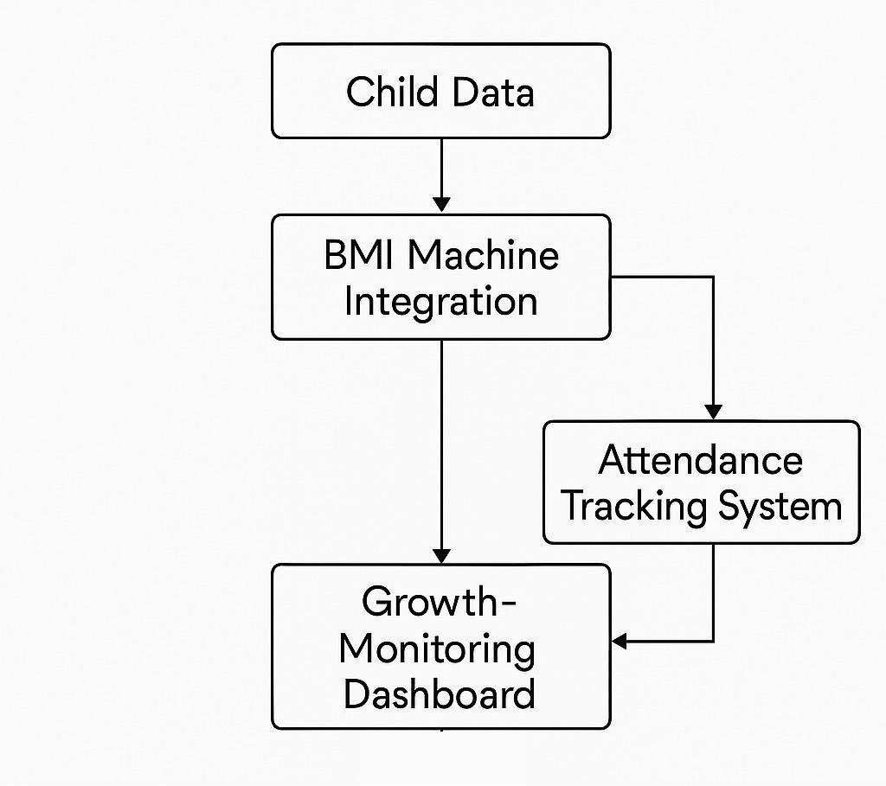

**Fig 3.3:Data Flow Diagram**

# CHAPTER 4 MODULE DESCRIPTION

The workflow for the proposed system ensures a smooth and effective process for monitoring child growth and attendance in Anganwadi centers. It consists of the following sequential steps:

# SYSTEM ARCHITECTURE

# USER INTERFACE DESIGN

# The sequence diagram in Fig 4.1 provides an illustration of how the interaction flow operates within the Anganwadi management system. Once a parent drops a child at the Anganwadi, an Anganwadi worker will extract the growth monitoring information through the Growth Monitoring Dashboard, and record the child's record of data. The next step is to mark attendance on the Attendance Tracking System. The Attendance Tracking System will securely store the child's attendance attendance and set communication flows with other stakeholders. After the Anganwadi worker records the child growth data, the relevant information is updated on the Community Engagement Platform to be able to send awareness messages or alert messages. Next, the Central Server will obtain the growth data, attendance data and engagement data from each of the modules so that all the data can be accessed and analyzed with no human effort. Parents have the ability to access detailed reports related to growth tracking, attendance history and monitor engagement in their home interface with the system. Effectively, the sequence diagram above addresses the facilitation of interaction, integrity of data, and real-time engagement of stakeholders.

# 

# Fig 4.1: SEQUENCE DIAGRAM

# BACK END INFRASTRUCTURE

# The backend of the proposed Anganwadi system offers significant architectural strength and security by supporting all of the core modules. All child growth data, attendance data, and community engagement updates are stored in a centralized database. Each module, including the Growth Monitoring Dashboard, Attendance Tracking System, and Community Engagement Platform, connect securely to the backend via established APIs. Data preprocessing logic ensures that data is structured and clean to feed into the system easily. Robust synchronization mechanisms enable data updates to be pushed to the Central Server in real time. The system will allow offline functionality with local storage activity so that if connectivity is restricted the user can input all essential data, which will auto-sync when the device becomes connected. The system's role-based access control will protect sensitive data by allowing access only to intended data records by authorized users. Because there is no shortage of regional language use in India, the multilingual capabilities of the system also mean maximum usability. The overall setup of the backend of the Anganwadi system will allow for optimal security, data integrity, and continuous access for all intended users.

# 4.2 **SYSTEM WORK FLOW**

**4.2.1 User Interaction:**

The users of the system - which are generally Anganwadi workers and parents - interact with the system via a straightforward web-based interface. Parents take their children to the center and then a worker keys in the height, weight, etc. into the system to begin data collection, while at the same time accessing growth reports and updates.

**4.2.2 Growth Data Collection & Processing:**

The system receives growth metrics - height, weight and age - via digital input expression from user input. The system then carries out a pre-processing procedure (to validate, 'clean', compute change in BMI, etc.) to create data that is robustly accurate. After the pre-processing completed, the data is presented on the Growth Monitoring Dashboard as a means of interpretation and view the trends over a period of time.

**4.3.3 Attendance Tracking Logic:**

In the center, the Anganwadi worker will record each child's attendance online. The attendance tracking system will electronically record child attendance information and transmit to a central server. The system accurately records attendance through timestamps and verifiable records of when children are seen for their growth monitoring.

**4.2.4 Notification & Feedback Mechanism:**

The system sends real-time alerts to parents and workers about missed visits, health risks, or engagement activities. The system can also be used to collect feedback from parents about services or ideas which supports transparency and improves the quality of service delivery.

# CHAPTER 5 IMPLEMENTATION AND RESULTS

# IMPLEMENTATION

The project utilizes a hybrid technology stack that includes React.js for a responsive frontend, along with HTML, CSS, and JavaScript for designing the interfaces. The backend is developed using Node.js and Python as well as Flask for handling the server logic and machine learning execution. A BMI machine is integrated into the project so that the system may capture health information such as height and weight, to be analyzed during the intended use of the system. Specific health metrics related to user activity are provided with the analysis. SQLite database management system stores and controls the data, and is lightweight and less demanding for a successful and effective process. Blockchain technology is designed for the project so that there are immutable activity logs. The records with blockchain technology are useful for sensitive data (e.g., health statistics and attendance) to prevent any change. The entire process is an all-inclusive, extensible, and comprehensive system that allows full confidence that the data and logs are secure for transparency and user experiences. User interactions and execution will promote frequent upgrades to a more efficient user experience.

# OUTPUT SCREENSHOTS

The project implementation is structured into modules, as depicted in Fig 5.1, highlights the project's seamless integration of machine learning for predictive analysis. It demonstrates a clear workflow, leveraging diverse data inputs for accurate results. The intuitive interface ensures usability across various platforms. Fig 5.2. showcases the project's machine learning model for detecting fake Instagram profiles. It highlights a streamlined workflow, utilizing account metrics for precise predictions. The system ensures adaptability and effective deployment for real-world applications. Fig 5.3 compares the confusion matrices of three classifiers: Gradient Boosting, Random Forest, and Support Vector Machine. It highlights models' performance in distinguishing between fake and non-fake profiles. The visual emphasizes accuracy and misclassification trends, aiding in selecting the best-performing algorithm. Fig 5.4 demonstrates the integration of a machine learning model within a Flask web application, enhanced with blockchain technology for data integrity. The app predicts fake Instagram profiles and securely logs each prediction as a blockchain block. This approach combines predictive analytics with tamper-proof record-keeping for robust and reliable deployment. Fig 5.5 illustrates a Flask web application designed for predicting fake profiles using machine learning. The interface accepts user inputs such as profile picture presence, username characteristics, and privacy settings to assess the authenticity of Instagram profiles. This tool combines user-friendly web design with predictive analytics to provide an accessible and efficient solution for detecting fake accounts. Fig 5.6 presents the prediction result page of the Flask web application. It displays the classification outcome, indicating that the profile is 'Fake,' along with a blockchain-generated hash to ensure the prediction's authenticity and tamper-proof record-keeping. The page includes a 'Go Back' button for navigation, offering a seamless user experience.

# 

Fig 5.1 Dashboard Summary

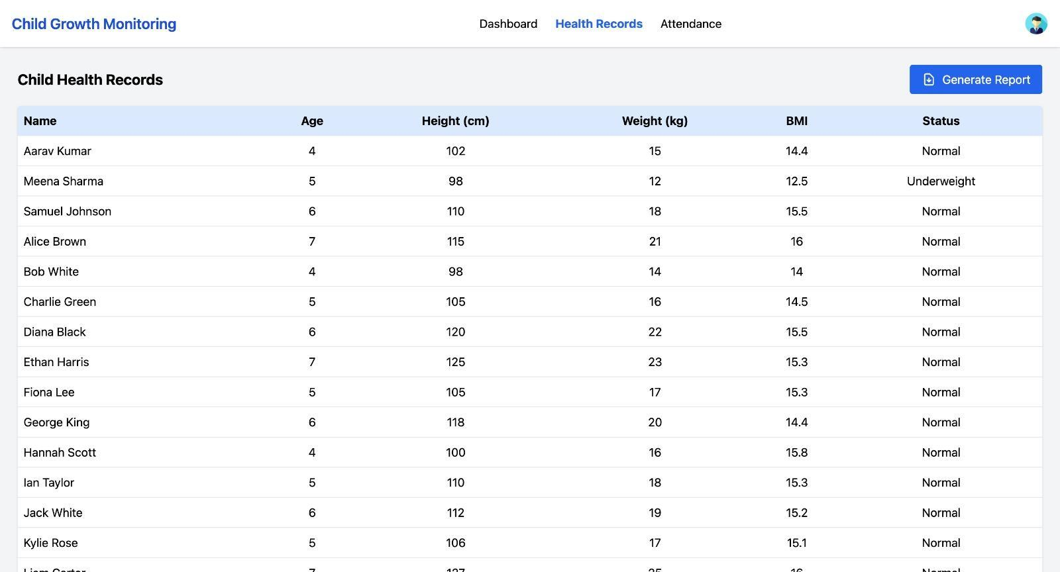

Fig 5.2 Children Health Records

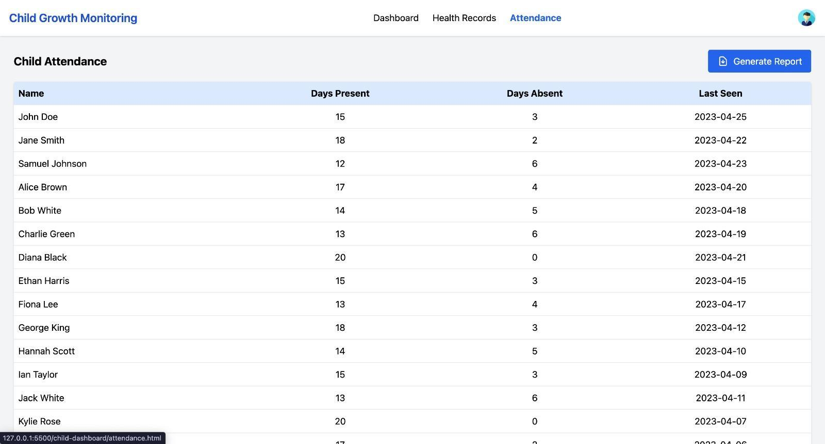

Fig 5.3 Children Attendance

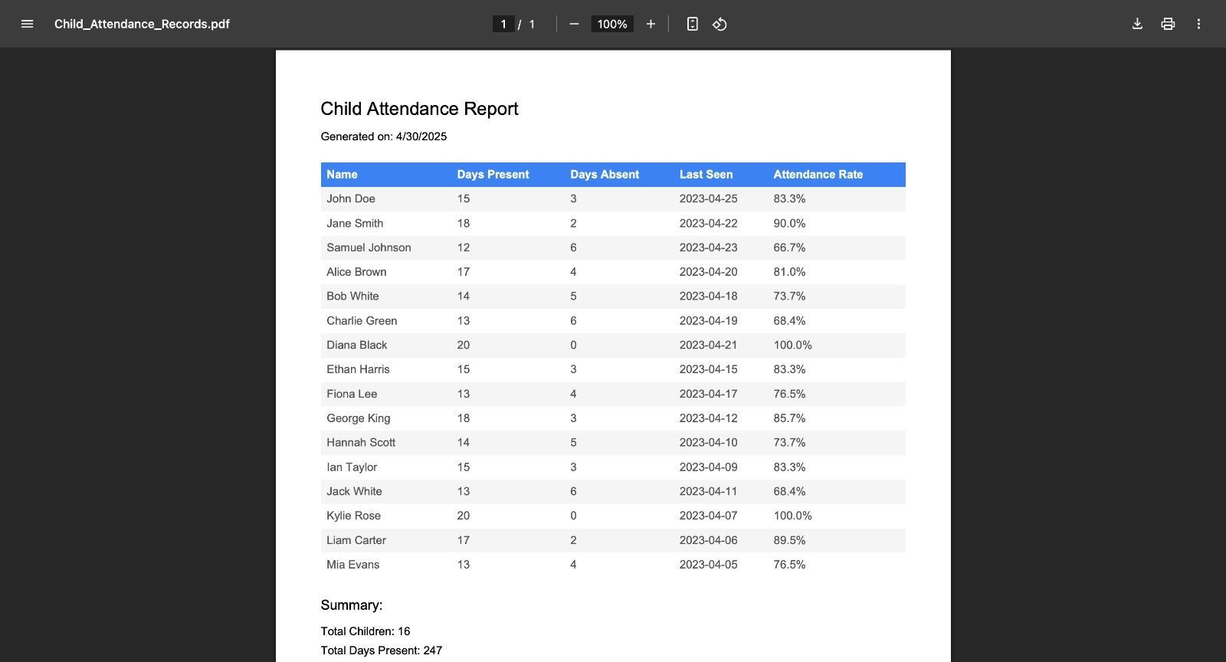

Fig 5.4 Children Attendance Report Generation

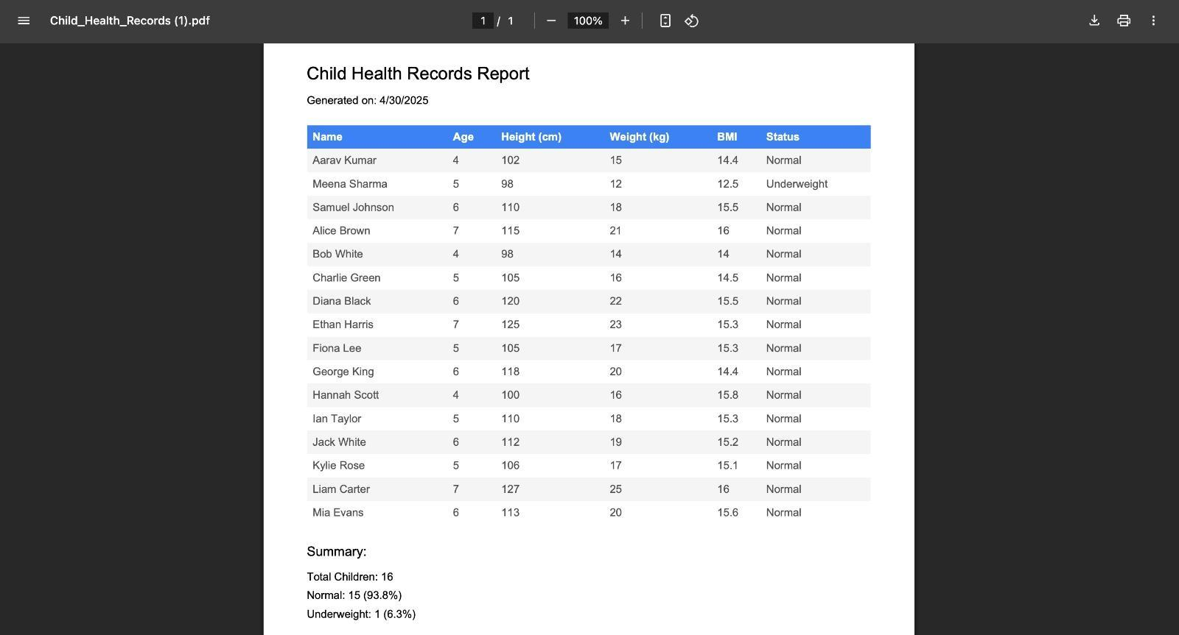

Fig 5.5 Children Health Records Report Generation

**CHAPTER 6**

**CONCLUSION AND FUTURE ENHANCEMENT**

# CONCLUSION

# The problems faced in traditional methods of monitoring child growth and attendance have been discussed. Several papers and journals related to child development monitoring and programs were studied and objectives were proposed. The system architecture and flow for the proposed solution were provided. The security issues, limitations with the existing physical, manual methods and the lack of public engagement have been highlighted in Phase I. Various articles and journals were examined, and goals were given. The suggested work's system architecture and flow were designed and completed.

# FUTURE ENHANCEMENT

In the future, enhancements to this solution could incorporate IoT-enabled BMI devices that can connect to the server-side out-of-the-box without any manual intervention, thus resolving all mistakes due to human involvement. AI-powered anomaly detection can be useful when determining expedited alerts to human administrators of unusual changes in growth in the physical domain or attendance as they occur. Advanced analytics and predictive modelling would enable us to identify and provide feedback on the probability of malnourishment or the likelihood of a child dropping out. AI-powered virtual assistants incorporated in the mobile app could provide immediate responses to parents' queries about the health and development of their child. Utilizing Aadhaar-based eKYC to process identity electronically may help improve accountability, and the continued implementation of blockchain to support integrations in all of ICDS, like tracking the nutrition supply chain can significantly help with accountability. Voice-based interfaces expand our support for more users, especially illiterate users in remote to benefit from our solution, especially if we establish a range of multilingual.

# REFERENCES

[1] Zhigang Gao, et al. "A Student Attendance Management Method Based on Crowdsensing in Classroom Environment" IEEE Access Volume: 9 (2021):31481 - 31492.

[2] Ji-Sung Park, et al. "Improving the Accuracy of Adult Height Prediction With Exploiting Multiple Machine Learning Models According to the Distribution of Parental Height" IEEE Access ( Volume: 11) 2023:91454 - 91471.

[3] Eduardo Segredo, et al. "SCHOOLTHY: Automatic Menu Planner for Healthy and Balanced School Meals" IEEE Access ( Volume: 8)2020:113200 - 113218 .

[4] Leire Bastida, et al. "Promoting Obesity Prevention and Healthy Habits in Childhood: The OCARIoT Experience" IEEE Journal of Translational Engineering in Health and Medicine ( Volume: 11) 2023:261 - 270.

[5] Qianwen Miao, Fu Xiao, Haiping Huang, Lijuan Sun, Ruchuan Wang "Smart attendance system based on frequency distribution algorithm with passive RFID tags" Tsinghua Science and Technology ( Volume: 25, Issue: 2, April 2020): 217 - 226.

[6] Hao Yang, Xiaofeng Han. "Face Recognition Attendance System Based on Real-Time Video Processing"IEEE Access ( Volume: 8),2020: 159143 - 159150.

[7]Viktor Erdélyi, Teruhiro Mizumoto, Yuichiro Kitai, Daiki Ishimaru, Hiroyoshi Adachi, Teruo Higashino. "Detecting Subtle Signs of School Attendance Issues Using Smartphone-Based Sensing." IEEE Access ( Volume: 13):4652 - 4669,2024.

[8] Hong-Danh Thai, Yeong-Seok Seo, Jun-Ho Huh. "Enhanced Efficiency in SMEs Attendance Monitoring: Low Cost Artificial Intelligence Facial Recognition Mobile Application" IEEE Access ( Volume: 12):184257 - 184274,2024.

[9] Tareq Alzubi, Raquel Fernández, JuliáN Flores, Montserrat Duran, José M. Cotos. "Improving the Working Memory During Early Childhood Education Through the Use of an Interactive Gesture Game-Based Learning Approach." IEEE Access ( Volume: 6):53998 - 54009, 2018.

[10] Catherine Akoth Ongoro, Yong-Yi Fanjiang. "Digital Game-Based Technology for English Language Learning in Preschools and Primary Schools: A Systematic Analysis."IEEE Transactions on Learning Technologies ( Volume: 17):202-228,2023.

[11] Jalal Safari Bazargani, Abolghasem Sadeghi-Niaraki, Fatema Rahimi, Tamer Abuhmed, Soo-Mi Choi. "An IoT-Based Approach for Learning Geometric Shapes in Early Childhood."IEEE Access ( Volume: 10):130632 - 130641,2022.

[12] Tamer Z. Emara, Joshua Zhexue Huang. "Distributed Data Strategies to Support Large-Scale Data Analysis Across Geo-Distributed Data Centers."IEEE Access ( Volume: 8):178526 - 178538,2020.

[13] Zhuofan Liao, et al. "Deep Learning-Based Data Storage for Low Latency in Data Center Networks." IEEE Access ( Volume: 7): 26411 - 26417,2019.

[14] Matthew P. Black, et al. "Automatic Prediction of Children's Reading Ability for High-Level Literacy Assessment."IEEE Transactions on Audio, Speech, and Language Processing ( Volume: 19, Issue: 4, May 2011):1015-1028.

[15] Dr Ashwini L, Dr Vinaykumar L, Dr Hanumanaik (2024). TELEMEDICINE AND RURAL HEALTHCARE ACCESS: A COMPARATIVE ANALYSIS OF EMERGING TECHNOLOGIES.Vol.31 No.11 JPTCP:169-179.

[16] Kristen J. Wells, Charles Preuss, Yashwant Pathak, J. K. Kosambiya and Ambuj Kumar(2012). ENGAGING THE COMMUNITY IN HEALTH RESEARCH IN INDIA. Technol Innov. 2012 April 1; 13(4).

[17] Raghavendra Ganiga, Radhika M Pai, Manohara Pai M M,Rajesh Kumar Sinha (2018). Private cloud solution for Securing and Managing Patient Data in Rural Healthcare System. Procedia Computer Science Volume 135, 2018, Pages 688-699.

[18] Theresia Chrisanthy Kustiawan , Siti Rahayu Nadhiroh , Roziana Ramli and Chaniphun Butryee(2022). Use of mobile app to monitoring growth outcome

of children: A systematic literature review. Digital Health Volume 8: 1–10.

[19] Sneha Kurian, Bansari L. Chawada(2023). Response and adaptations made by the integrated child development services stakeholders towards the digitalisation of its record keeping systems of the Anganwadi centres in urban Gujarat, India. International Journal of Community Medicine and Public Health | October 2023 | Vol 10 | Issue 10 Page 3848-3852.

[20] Mayuri Raul (2024). Attendance in Anganwadi centres through Anganwadi workers’ lens: A Force Field Analysis in Urban slum. Indian Journal of Community Medicine ¦ Volume 49 ¦ Issue 7 ¦ Supplement 2024.